The Bureau

# Objective

A new president and his cabinet have been elected to run the country, and you have been tasked with staffing the Bureau of Information. Your job collectively as a team is to see that the correct documents (coloured cards designated Military, Government and Media) get to the correct organisations within the time allowed by the game. Players may have to negotiate between them to ensure the correct number of reports are able to be submitted within each round. If all of the correct reports are submitted before the phones timer runs out the team wins – failure to submit all of the required reports (the cards) on time means the team loses and the phone wins.

# Setup

This game requires a smartphone running Android, with the Bureau app installed.

1. One person should shuffle the pack of cards and deal out 5 to each player and place the remaining deck face down anywhere in reach of all players. Leave space for a discard pile nearby.
2. Place the phone with the app running, in the centre of the table where it can be seen by all players. Leave space near it to place the ‘submitted’ report cards
3. Press play on the app when you are ready to play.

# Rules of Play

During play, your phone will ask for you as a team to provide an amount of a certain colour report (red for Military, yellow for Government or blue representing the Media) into the middle of the table (the discard pile). Only one player per round can submit these reports by placing them face up in the discard pile. Each round as dictated by the phone is played collaboratively by all players simultaneously.

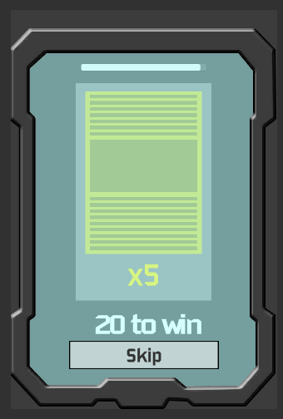

Skip the round at the cost of a time penalty

How many rounds remain

The amount of reports required

Total game time left

The report type being requested

Only one player may submit the reports. Once these correct number and type of reports are placed in the centre any player should touch the centre of the phone to progress onto the next round.

If however no players can satisfy the report demand, one of two things can then happen:

* Players may trade reports in batches of 3 with another player – any combination of colours can be traded per trade. Players whom have already traded cannot trade with the same person until the next round. Trades between 2 players must happen simultaneously i.e. both sets of 3 cards are exchanged at the same time from your existing 5 card deck – the 3 exchanged cards cannot be added to a players deck and then they decide which 3 cards to offer back in exchange.
* Alternatively, players may press the “skip” button on the phone, discard all 5 of their cards and draw 5 fresh cards from the deck at the cost of a time penalty. The impact of “skipping” is to reduce the total game play time by 20 seconds. This makes it harder to complete all 20 rounds.

After the correct number of the required coloured reports have been submitted the player who submitted them draws up fresh cards to bring their total back to five. If the draw pile is not large enough to draw back up, shuffle the discard pile back into the draw pile, and draw as normal.

Play continues until all requirements have been satisfied in which case the team wins, or the timer runs out and the phone wins (i.e. the team loses).

-------------------------------------------------------- -----------------------------------------------------------------------------